CAPSTONE PROJECT WEEKLY ACCOMPLISHMENT REPORT

Team Name: COREX Section: BSIT-3A Date: February 9-13
Project Title: Prime Connect: Smart Management and Growth Platform

Accomplishment for the Week

Task / Activity | Description of Work Done | Output / Evidence
Preparing the Concept Paper | The concept paper was reviewed to confirm that the study's objectives, problem statement, proposed solution, and significance were clearly articulated. | 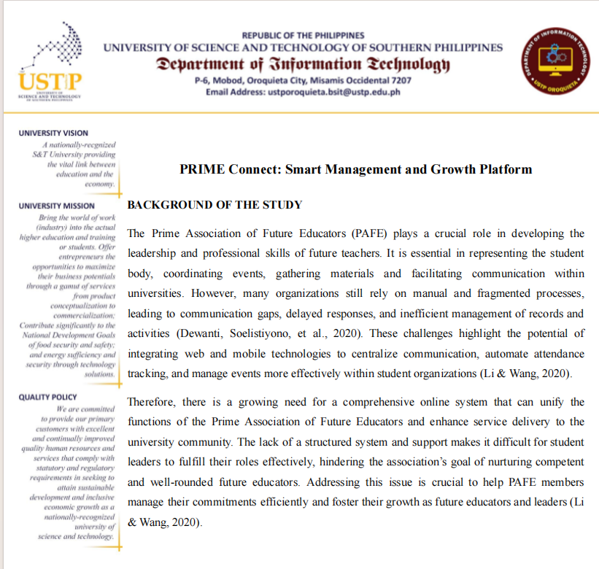
Creating Pitch Deck | The group has created slides that distill the concept's primary problem and its corresponding solution. |   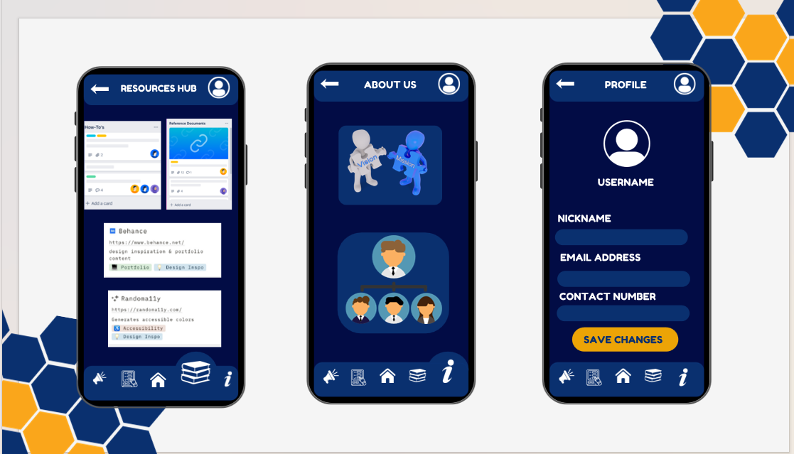
Concept Hearing/Proposal  (February 11) | Presented a comprehensive system proposal to the panelist, discussed the project objectives, scope, and methodology while integrating expert feedback into the development plan. | We present our concept hearing and received feedback from panelist.
Process  Design for  New System  (Event Scoring and Tabulation) | The process and  procedure of the  suggested systems were designed and organized according to regarding adviser comments and system specifications. | 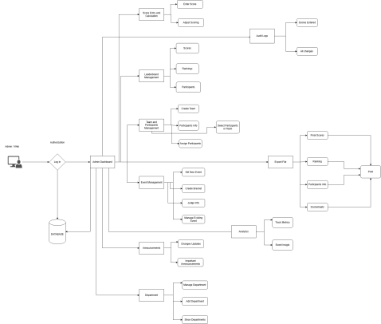

Individual Contribution

Team Member | Contribution
Gellyn S. Rabino | Documenter
Arlyn Kaye Allona D. Baluyos | Quality Assurance
Johny M. Roldan | Data / Analysis Specialist
Ian Kirby B. Duman-ag | Project Manager / Team Leader

Issues Encountered and Actions Taken

Issue/Concern | Action Taken / Resolution
Revisions required after Concept Hearing | Revised system procedure and concept paper based on comments
Revised Concept Paper | Revised Concept Paper with suggestions  and completed system information

Plan for the Next Week

Planned Task | Expected Output
Preparation of Revised Concept Paper | Revised Concept Paper with suggestions  and completed system information
Preparation for Second Concept Hearing | Finalized and finished presentation materials for  The second Concept of Hearing

Adviser’s Remarks

Reviewed by:

Mr. Hanes A. Ongos
Capstone Project Adviser
Date Signed:

Note:

- This report shall be submitted weekly to the Capstone Adviser.
- All members must actively contribute and be reflected in the report.
- Supporting evidence (screenshots, documents, commitments, etc.) may be attached.
- Submission of this report forms part of the progress monitoring and individual assessment of the Capstone Project.

